

National University of Science and technology

(NUST)

**CS-114 - Fundamental of Programing**

**Lab Manual # 02**

**Course Instructor: Dr Jawad Khan**

**Lab Instructor: Muhammad Affan**

**Student name:** Muhammad Uzair

**QALAM ID:** 477228

**Date: 04/10/2023**

**TASK 1:**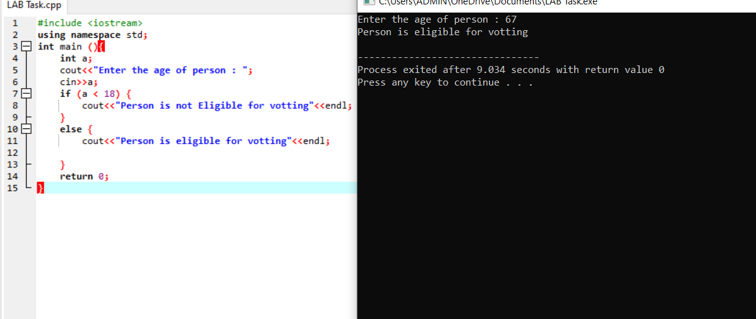

**TASK 2:**

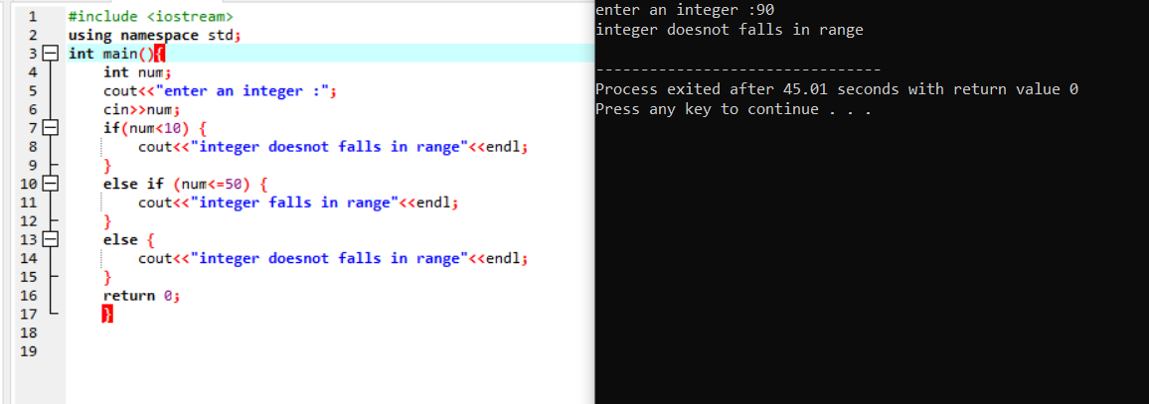

**TASK 3:**

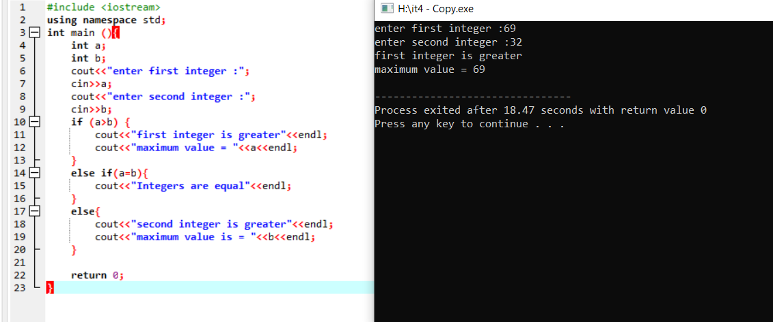

**TASK 4:**

